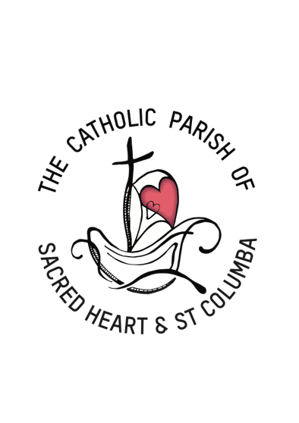
The Catholic Parish
of Sacred Heart and St Columba
Our Parish is a Christian community which welcomes all to walk together
in a spirit of compassion, justice and hope.
Our Parish is committed to the safety, wellbeing and dignity
of all children and vulnerable adults.

Child Safety Report for 3 November 2022 PLDT meeting

Professional Standards Unit (CAM)

The Safeguarding Essentials online training is a compulsory, annual 30-minute training module for clergy (staff) and volunteers within the Catholic Archdiocese of Melbourne (CAM).

The purpose of this training is to provide our clergy, (staff) and volunteers with:
- foundational knowledge that will help them to perform their roles
- a clear understanding of their duty of care and of expectations with regards to safeguarding children, young people and adults from all forms of abuse and harm
Our Safeguarding Committee has discussed the roll out of the training and will be approaching it in three main ways:

- Email to parishioners with background information and request to complete training online.
- A session/s after mass where parishioners can watch training in a group context.
- Offer to attend the parish for group or online training with Jane.

We again ask that PLDT members complete the training as we will be including that as part of the information to parishioners.

Please follow this link and the instructions provided.
https://safeguarding.melbournecatholic.org/s/login/?ec=302&startURL=%2Fs%2F

New Victorian Child Safe Standards

Tamara Cugnatto from the Professional Standards Unit will be meeting with our Safeguarding Committee in mid November to undertake our 2022 progress review. We have prepared a draft of the new Standard 1 relating to Aboriginal children and young people.

